***PAAREES PERFUMES***

***CALVIN KLIEN***

***FOR WOMEN***

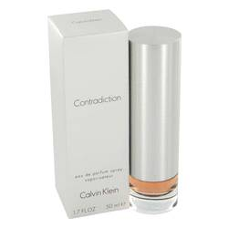

# 

***CONTRADICTION***

## *Description:*

Contradiction by Calvin Klein Perfume. Contradiction by Calvin Klein is a sensuous, revitalizing fragrance for today's woman. Created by Calvin Klein in 1998, Contradiction represents the next evolution of femininity. This best seller features an intoxicating mixture of rose, peony, lily-of-the-valley and false jasmine top notes with heart notes of orchid and syringa. A base of sandal and tonka bean rounds out the fragrance. Wear Contradiction for work or play. It is the perfect fragrance to captivate and intrigue everyone you encounter.