***PAAREES PERFUMES***

***CALVIN KLIEN***

***FOR WOMEN***

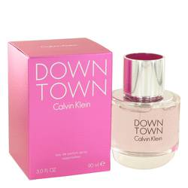

# 

***DOWNTOWN***

## *Description:*

Downtown by Calvin Klein Perfume. Created in 2013 by Calvin Klein, Downtown for women has a bewitching appeal that enthralls women of any age. This exhilarating fragrance combines the citrusy note of Italian lemon and bergamot with the delectable notes of pear and plum to create a feminine scent that is not at all overwhelming and lasts for hours after application. Choose Downtown for a scent that is ideal for any occasion and leaves you with the power to attract positive attention.