***PAAREES PERFUMES***

***CALVIN KLIEN***

***FOR WOMEN***

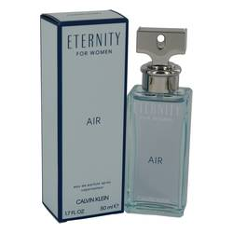

# 

***ELERNITY AIR***

## *Description:*

Eternity Air by Calvin Klein Perfume. Eternity Air is a breezy combination of floral and citrus accords that makes you feel as if you are in a field of flowers under the open sky. This newest flanker of the Eternity line was introduced in 2018. It opens with ozonic notes, black currant and grapefruit, creating a light, fresh and slightly tart beginning. The heart of the fragrance contains lily-of-the-valley and peony, resulting in a center that is floral, but tempered by the sweet fruitiness of pear. The fragrance closes with cedar, ambergris and musk, giving the perfume a sensuous finish.