***PAAREES PERFUMES***

***CALVIN KLIEN***

***FOR WOMEN***

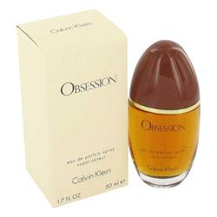

# 

***OBSESSION***

## *Description:*

Obsession by Calvin Klein Perfume. Introduced by Calvin Klein in 1985, Obsession is a women's fragrance that is impossible to forget. As iconic as a beloved movie scene or a famous landmark, this signature scent gives you an effortless sense of poise and confidence. Refreshing notes of bergamot, mandarin orange and peach blend with the warmth of vanilla and a spicy hint of basil. Turning heads is easy when you are wearing a fragrance as distinctive as Obsession from Calvin Klein.