***PAAREES PERFUMES***

***CALVIN KLIEN***

***FOR WOMEN***

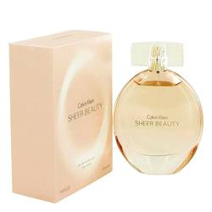

# 

***SHEER BEAUTY***

## *Description:*

Sheer Beauty by Calvin Klein Perfume. Feel cool and confident every day with Calvin Klein's Sheer Beauty fragrance for women. This elegantly understated scent was introduced in 2010. Zesty and fruity top notes of bergamot, red berries and peach Bellini entwine with floral notes of peony and pink lily to deliver a delightful bouquet that lifts your spirits. This scent is equally appropriate for formal and casual occasions, so you can wear it for a business meeting with clients, a trip to the mall with your friends or a dinner date with someone special..