***PAAREES PERFUMES***

***CALVIN KLIEN***

***FOR WOMEN***

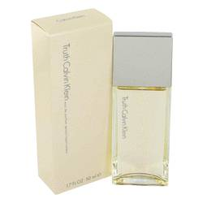

# 

***TRUTH***

## *Description:*

Truth by Calvin Klein Perfume. A surprising blend of woodsy scents and citrus-like aromas, Truth by Calvin Klein lends you a unique, refreshing note. Released in 2000, this both sensual and uplifting fragrance for women builds a fresh presence with soft hints of sensuality. It mixes the natural, earthy scents of vetiver and bamboo with cheering notes of bergamot and lemon. Patchouli tones add a romantic feel to the woodsy fragrance, making it a remarkable fit for feminine tastes that lean towards being different.