***PAAREES PERFUMES***

***Christian Diors***

***FOR MEN***

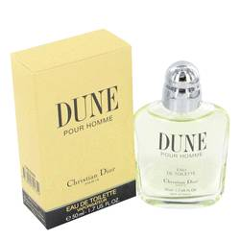

# *Dune*

***Description:***

Dune by Christian Dior Cologne. Let a splash of Dune envelop you in a cloud of inspiration to carry you through a busy work day. As a Christian Dior blend, this men's fragrance is bold and balanced. A base of fig wood bark is layered with middle notes of fig leaf and cassis. Sharp herbs like basil and sage bring a sense of mystery to the combination. Fans of the Dior fragrances have been enjoying this scent since it was created in 1997.