***PAAREES PERFUMES***

***Christian Diors***

***FOR MEN***

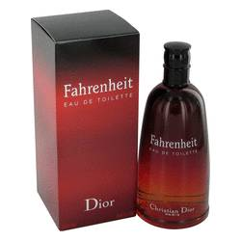

# *Fahrenheit*

***Description***

Fahrenheit by Christian Dior Cologne. The moment your lady catches a whiff of Fahrenheit for men, the temperature in the room is sure to rise. This classic scent was first introduced by Christian Dior in 1988, yet it continues to gain a following because of its delicious mingling of scents that never goes out of style. Touches of lavender, mandarin orange and hawthorn are followed by subtle masculine aromas of nutmeg flower and cedar. Each note is a perfect complement to the others, resulting in a delightfully unforgettable scent.