***PAAREES PERFUMES***

***Christian Diors***

***FOR MEN***

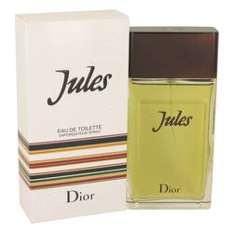

# *Jules*

***Description***

Jules by Christian Dior Cologne. Jules is a man with masculine elegance. He isn’t easily swayed by trends, and others admire his classic tastes. His cologne is fresh and spicy with top notes of Artemisia, lavender, cumin and bergamot over heart notes of jasmine, cyclamen, cedar, basil, rose and sandalwood. Leather, tonka bean, oak moss, amber, suede and musk give the mix a manly base. Try a dab of this aromatic cologne to see what Jules can do for you.  
  
This cologne was created by exclusive designer Francois Demachy for Christian Dior. Crafting “New Looks” since 1947, each of this brand’s fragrance accords is made using the finest ingredients blended into unique combinations. This process can take several years in some cases. In production, raw materials are weighed by hand, left to mature and closely monitored. Each fragrance label is placed by hand to ensure an optimal fit that complements the contours of the bottle.