***PAAREES PERFUMES***

***Christian Diors***

***FOR MEN***

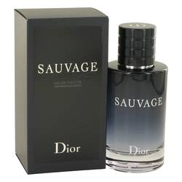

# *Sauvage*

***Description***

Sauvage by Christian Dior Cologne. Sauvage by Christian Dior is perfect for any man who wants to unleash his wild side. Although this fragrance came out in 2015, it is based off a much older cologne that was released in the 1960s. This fragrance is inspired by the idea of running in an open space with a clear blue sky above you. This product has a highly masculine scent with top notes of Calabrian bergamot and pepper. The heart contains patchouli, pink pepper, Sichuan pepper, geranium, vetiver, elemi and lavender. The rugged base consists of ambroxan, labdanum and cedar.  
  
Christian Dior is a premier French fashion designer. Over 100 perfumes have been released under the company’s name. For Sauvage, Francois Demachy was brought on to develop the composition. Demachy like to draw inspiration for many of his fragrances from the Mediterranean climate. The face for this cologne’s ad campaign when it was first released was Johnny Depp.