***PAAREES PERFUMES***

***CHRISTIAN DIOR***

***FOR UNISEX***

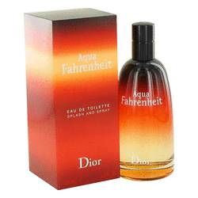

# 

***AQUA FAHRENHIET***

## *Description:*

Aqua Fahrenheit by Christian Dior Cologne. Designed exclusively for men, Christian Dior presented Aqua Fahrenheit in 2011. The citrus blend of sweet mandarin orange and tangy grapefruit invitingly draw in the wearer while creating a setting for the middle notes of earthy violet, fresh basil and cooling mint. Its distinctive bottom notes feature the smoky, woody scent of vetiver with hints of bitter chocolate, which accompanies the excitingly rich smell of leather. Bold and masculine, this scent is ideal for a self-assured man.