***PAAREES PERFUMES***

***Christian Diors***

***FOR WOMEN***

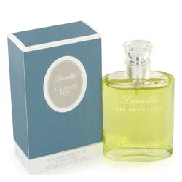

# *Diorella*

***Description:***

Diorella by Christian Dior Perfume. Diorella is a fresh, soft women's fragrance created by Christian Dior in 1972. Lush green notes, combine with woodsy oakmoss, spicy basil, sweet honeysuckle and floral bergmot to give this timeless fragrance an invigorating scent. To further enhance this light, citrus fragrance, subtle peach heart and vetiver are added to brighten up the aroma. Recommended for daytime wear, Diorella stays fresh throughout the day and well into the evening for those "after-work" activities. For a surprisingly fresh aromatic experience, try Diorella today.