***PAAREES PERFUMES***

***Christian Diors***

***FOR WOMEN***

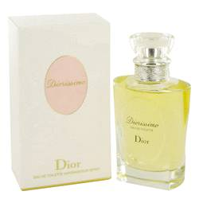

# *Diorissimo*

***Description:***

Diorissimo by Christian Dior Perfume. Let yourself relax over the weekend by doing something out of the ordinary, like visiting a museum or an art exhibit, and wear Diorissimo by Christian Dior for that added feeling of sophistication. Made for women, Diorissimo has been the choice of bold women for generations, having been introduced in 1956. The scent's flowery fragrance from the mix of rosemary, lily and lilac has been the weapon of choice of many women who know just how powerful charm can be.