***PAAREES PERFUMES***

***Christian Diors***

***FOR WOMEN***

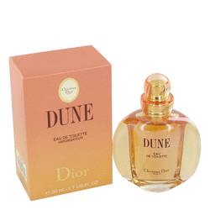

# *Dune*

***Description:***

Dune by Christian Dior Perfume. Escape the real world and surround yourself with the romantic and soothing scent of Dune for women, a smooth and sensual fragrance created by Christian Dior in 1991. Reminiscent of warm sand and fresh ocean breezes with just a hint of floral undertones, this inspiring fragrance contains notes of bergamot, mandarin, palisander, aldehyde and peony. Possessing a moderate to heavy aroma, this scent is ideal for evening wear, special occasions and times when you're in a romantic mood.