***PAAREES PERFUMES***

***Christian Diors***

***FOR WOMEN***

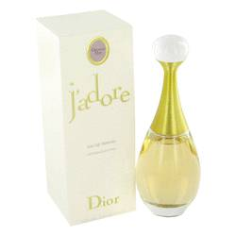

# *Jadore*

***Description:***

Jadore by Christian Dior Perfume. The epitome of feminine grace, J'adore by Christian Dior has inspired a long and popular line of variants. The original, launched in 1999 by the trailblazing French fashion and fragrance brand, offered an exquisite interpretation of the familiar floral and fruity composition. Irresistibly intoxicating magnolia is matched with tart bergamot, crisp pear, luscious peach, and refreshing melon. An instant classic upon its release, Dior's J'adore for women captures its creator's glamorous appeal in fine fragrance form.  
  
J'adore perfume is the ideal fragrance for women who are professional and stylish. It has a scent that is feminine yet commanding and is perfect for today's modern woman.