***PAAREES PERFUMES***

***Christian Diors***

***FOR WOMEN***

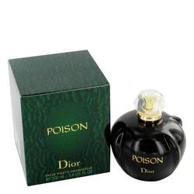

# *Poison*

***Description:***

Poison by Christian Dior Perfume. Release your inner diva and celebrate your sultry side with every spritz of Poison perfume, a decadent fragrance for women who are elegant and sophisticated yet seductive and alluring. Launched in 1985 by the design house of Christian Dior for the provocative woman who demands a fragrance that as seductive and sexy as she is, this sweet yet heady scent features robust notes of incense, tuberose, plum, cinnamon and white honey. You'll adore the irresistible aroma of this popular scent, which is sure to turn heads wherever you go.