***PAAREES PERFUMES***

***THIERRY MUGLER***

***FOR MEN***

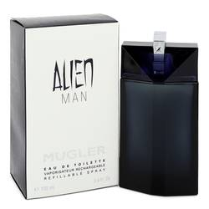

# 

***ALIEN FUSION***

## *Description:*

## Alien Man by Thierry Mugler Cologne. Encounter something out of this world when you spritz on Alien Man, a highly original men's fragrance. This enigmatic cologne combines spicy, aromatic and green accords for an all-natural burst of vibrancy with every new application. Top notes of zesty lemon, relaxing lavender, herbal thyme, cool mint, anise, dill and beech blend together to create an energetic and captivating introduction. Heart notes of bold black pepper, red geranium, osmanthus, soft cashmere wood and masculine leather incorporate a more refined and mysterious approach. Finally, base notes of blissful vanilla, cashmeran and sensual white amber lend a softer tone that winds down the intensity and balances the entire concoction. Perfect for all day wear or special occasions.