***PAAREES PERFUMES***

***THIERRY MUGLER***

***FOR MEN***

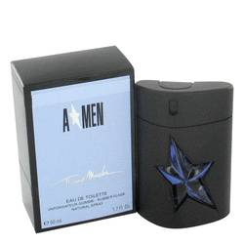

# 

***ANGEL***

## *Description:*

Angel by Thierry Mugler Cologne. Enhance your persona when you wear Angel by Thierry Mugler. First introduced in 1992, this men's fragrance melds earthy notes of amber with delicious and sweet dark chocolate, honey, vanilla and creamy caramel for a sublime aroma that attracts others to you. Wear it whenever you want to stand out from the rest of the pack. This masculine scent pairs well with anything in your wardrobe, from casual wear to a white tux and tails.

## .