***PAAREES PERFUMES***

***THIERRY MUGLER***

***FOR MEN***

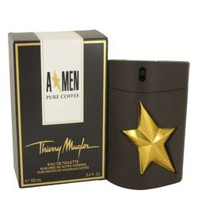

# 

***ANGEL PURE COFFEE***

## *Description:*

Angel Pure Coffee by Thierry Mugler Cologne. Thierry Mugler’s Angel Pure Coffee is a twist on its original Angel cologne. The sharp, amber aromas of the original have been altered to suit the addition of rich, dark coffee scents. Make no mistake, this is bold, powerful cologne is an attention getter. In addition to the addictive smell of coffee, notes of musk complement the spicy and sweet mixture of patchouli and vetiver. Cedar notes were chosen to lend the earthy smell of leather to an already heady cologne. This luxurious fragrance is the perfect accompaniment to a formalwear evening. A dynamic man wishing to hint at his commanding personality might also choose a light layer before a daytime event.