***PAAREES PERFUMES***

***THIERRY MUGLER***

***FOR MEN***

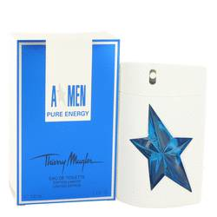

# 

***ANGEL PURE ENERGY***

## *Description:*

Angel Pure Energy by Thierry Mugler Cologne. Thierry Mugler’s Angel Pure Energy is exactly what it says in the name: an invigorating scent that will energize you for your whole day. The tone of the fragrance is set by the inviting combination of white amber resin and Indian jasmine. The top notes include the refreshing combination of mint and juniper berries. The heart of the scent adds depth with the spicy scents of white pepper and cardamom. The base notes feature the sweet scent of patchouli, but the unusual inclusion of sequoia gives Angel Pure Energy a unique, masculine quality. Because of its invigorating scent, most men will prefer to use it as a daytime cologne in warmer weather. However, the use of spices and woods means that this is cologne has a personality that’s strong enough to be worn for evening events.