***PAAREES PERFUMES***

***THIERRY MUGLER***

***FOR MEN***

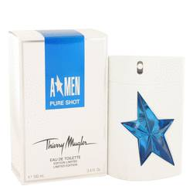

# 

***ANGEL PURE SHOT***

## *Description:*

Angel Pure Shot by Thierry Mugler Cologne. Turn heads when you enter any room wearing this Angel Pure Shot fragrance for men. Designed by Thierry Mugler and released in 2012, this exciting fragrance sets you apart as a man who is confident and isn't afraid to flaunt it. The scent opens with a spicy start that slowly gives way to a woody middle that is accentuated by juniper berries. A base of cardamom gives it a memorable finish that sticks with you for hours after application.