***PAAREES PERFUMES***

***THIERRY MUGLER***

***FOR MEN***

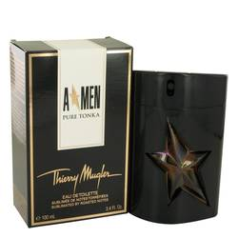

# 

***ANGEL PURE TONKA***

## *Description:*

Angel Pure Tonka by Thierry Mugler Cologne. A spritz of Angel Pure Tonka and you are transported to a lush forest. Oriental with accords of vanilla, coffee, spices and woods, this fragrance will take you from the boardroom to the bedroom. You are greeted with a top note of fresh mint followed by a heart accord of aromatic lavender. A rich, sultry base of licorice, tonka bean, vanilla, cacao, coffee and vanilla will make your wrist smell good enough to eat. Launched in 2016, this 3.4-ounce eau de toilette comes packaged in a striking ebony flacon emblazoned with a star-shaped gem.