***PAAREES PERFUMES***

***THIERRY MUGLER***

***FOR MEN***

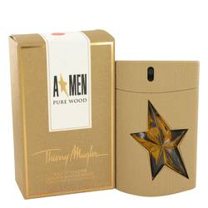

# 

***ANGEL PURE WOOD***

## *Description:*

Angel Pure Wood by Thierry Mugler Cologne. Perhaps no scent is more associated with masculinity than the earthy fragrance of wood. Wood scents are often used in perfume-making to provide the strength and rustic qualities of the forest. Thierry Mugler chose to play off this by creating Angel Pure Wood, a cologne dedicated to this classic, manly scent. The cologne has a smooth quality to its fragrance through the inclusion oak wood, vanilla and coffee. Warm patchouli gives this balanced fragrance a touch of character. The spicy scent of cypress contains just a hint of evergreen, adding the fresh, clean smell of woodland air. Although distinct, the cologne is not so overpowering that it can’t be worn during the day.