***PAAREES PERFUMES***

***THIERRY MUGLER***

***FOR MEN***

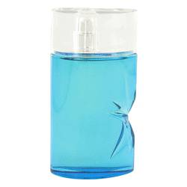

# 

***ANGEL SUNESSENCE***

## *Description:*

Angel Sunessence by Thierry Mugler Cologne. Start off your day or head off into the evening with a refreshing splash of Angel Sunessence. Introduced to the world in 2009, this energizing men's fragrance by Thierry Mugler features notes such as the citrusy tang of bergamot and the light, fresh scent of hibiscus flowers. Thanks to a pleasing bouquet that is masculine without being overwhelming, this wonderful fragrance is perfect whether you're out on the slopes or running a meeting in the boardroom.