***PAAREES PERFUMES***

***THIERRY MUGLER***

***FOR MEN***

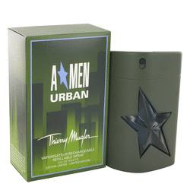

# 

***ANGEL URBAN***

## *Description:*

Angel Urban by Thierry Mugler Cologne. Thierry Mugler has created a cologne with all the romance and mystery of the modern city with its Angel Urban. The scent combines the aromas of ethnic cuisines with the darker, thicker scents that represent the character of a city. The fragrance begins with the introduction of cilantro, mint, lavender, foliage and bergamot in diverse combination of aromatic herbs and fruit. The middle notes contain the sweetness of caramel and milky honey balanced by the spicy scents of cedar wood, patchouli and woodland lily. The base notes are musk, vanilla, amber, styrax balsam and sandalwood. Real depth of personality is suggested by the contrast between the refreshing top notes and darker base notes. The balance of fragrances creates a versatile cologne that can be worn for almost any occasion.