***PAAREES PERFUMES***

***THIERRY MUGLER***

***FOR MEN***

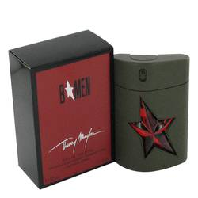

# 

***B MEN***

## *Description:*

B Men by Thierry Mugler Cologne. Add excitement to your day whenever you wear B Men by Thierry Mugler. Launched in 2004, this captivating scent entices others with its swirling notes of musk and violet mixed with exotic patchouli, leather and spicy accords. This scent is ideal for use any time of the day or night. Wear it on well-planned, leisurely boat rides under the midafternoon sun with someone special or during impromptu gatherings of old friends on long holiday weekends.