***PAAREES PERFUMES***

***THIERRY MUGLER***

***FOR UNISEX***

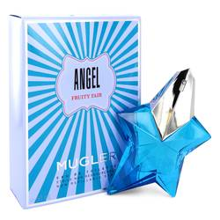

# 

# Angel Fruity Fair

## *Description:*

Angel Fruity Fair by Thierry Mugler Perfume. Joie de vivre; in English, this translates to “the joy of life,” but it means so much more than that. It’s the essence of spirit – a philosophy that sharing kindness and camaraderie is the ultimate of human existence. Thierry Mugler Angel Fruity Fair perfume was launched in 2018 to celebrate this approach to living. The top is an invitation to a utopian world; shyly sweet blackberry meets tropical, fruity lychee for an inviting accord. The heart is a whirlwind of intensity with fresh rose thorn core adding a seductive quality, while undertones of pomarose add a slightly fruity rose scent. Delicious whipped cream and vanilla adds a delightfully scrumptious aroma, while patchouli is powdery and herbal in the dry-down. Part of the oriental gourmand fruity fragrance family, it’s mellow while having a definite sillage and compelling allure.