***PAAREES PERFUMES***

***THIERRY MUGLER***

***FOR UNISEX***

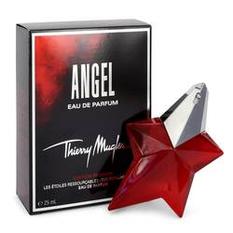

# 

***ANGEL PASSSION STAR***

## *Description:*

Angel Passion Star by Thierry Mugler Perfume. Launched in 2015, Angel Passion Star is a sweet fruity women’s fragrance. The perfume opens with notes of cassis, mandarin orange, cotton candy, melon, bergamot, coconut and jasmine. The middle blossoms with floral notes of jasmine, rose, orchid and lily of the valley combined with fruity notes of plum, red berries, blackberry, apricot and honey. Notes of amber, musk, tonka bean and patchouli ground the base while chocolate, caramel and vanilla continue the sweetness to the end. The long-lasting fragrance has an oriental vanilla essence transferring easily from day to night. The perfume is housed in a passionate red star bottle reminiscent of 1940s Hollywood glamour.