***PAAREES PERFUMES***

***THIERRY MUGLER***

***FOR UNISEX***

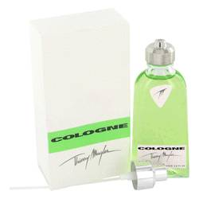

# 

# COLOGNE

## *Description:*

Cologne by Thierry Mugler Cologne. Cologne by Thierry Mugler is a clean fragrance for men created in 2001. It possesses the unique notes of sweet bergamot, rich neroli, fresh petitgrain, African orange flower and heady musk. This is a scent for the ruggedly athletic man who thinks nothing of working a 12-hour day and then heading off to the gym for an intense 3-hour workout. Recommended for both day and evening wear, Cologne is a vibrant blend of aromatic undertones especially created for the cosmopolitan man.