***PAAREES PERFUMES***

***THIERRY MUGLER***

***FOR WOMEN***

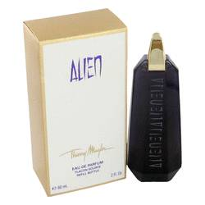

# 

***ALIEN***

## *Description:*

Alien by Thierry Mugler Perfume. The dramatic flourish of Indian jasmine with its intensely warm heart runs through the core of Alien by Thierry Mugler. Unsettling, hypnotic, and transporting, Alien is a top seller that is long lasting. The plush of white amber, the austerity of woods, and the tingling citrus notes produce an original elixir encased in the most unique purple bottle with gold accents in the cap.