***PAAREES PERFUMES***

***THIERRY MUGLER***

***FOR WOMEN***

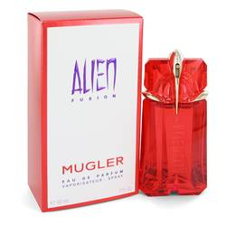

# 

***ALIEN FUSION***

## *Description:*

## Alien Fusion by Thierry Mugler Perfume. A soft, beautifully feminine fragrance for four-season wear, Alien Fusion is a hazy white floral scent enhanced by amber and spice. The opening mingles subtle citrus nuances of neroli with warm spice accords of cinnamon and ginger. Lush and lovely tuberose blooms at the heart, interfused with sensual tones of jasmine and orange blossom. Magnetic white amber and vanilla in the base notes create a serene yet definitely sensual, captivating trail.