***PAAREES PERFUMES***

***THIERRY MUGLER***

***FOR WOMEN***

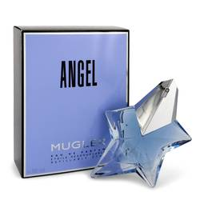

# 

***ANGEL***

## *Description:*

Angel by Thierry Mugler Perfume. Angel is a worldwide top seller and was first bottled in 1992 by Thierry Mugler. Angel features an uplifting and spirited blend of sweet, floral scents. Angel perfume by Thierry Mugler features dreamy notes with a sweet coconut and flowery jasmine opening that drifts into a heart of honey before a spicy finish of patchouli and bergamot. Apply this cherubic scent whenever you want to create a demure, innocent vibe. For any fan of Thierry Mugler, Angel perfume is the perfect signature scent.

.

## .