***PAAREES PERFUMES***

***THIERRY MUGLER***

***FOR WOMEN***

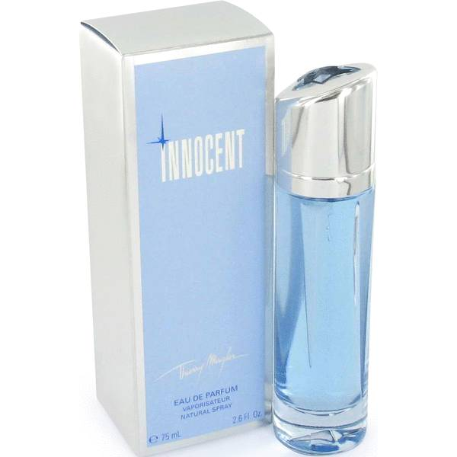

# 

***ANGEL INNOCENT***

## *Description:*

Angel Innocent by Thierry Mugler Perfume. Angel Innocent is a gourmand fragrance for young, vibrant women. Introduced in 1998, this Thierry Mugler creation is recommended for women who love the label's Angel scent but want to take things further. Pure, delicate and clean, this feminine fragrance features a bouquet of intoxicating notes, including Mandarin orange, bergamot, black currant, almond and red berries. Flirty and fun, Angel Innocent is perfect to wear to a romantic dinner date or a fun night out.