***PAAREES PERFUMES***

***THIERRY MUGLER***

***FOR WOMEN***

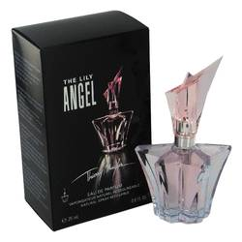

# 

***ANGEL LILY***

## *Description:*

Angel Lily by Thierry Mugler Perfume. Le Lys, french for Lily, is a delicate floral-oriental fragrance. The note is both magical and sensual, one that plays with majestic lily flower and a rich floral-honey notes. The magical bottle is shaped like a flower starting to bloom.