***PAAREES PERFUMES***

***THIERRY MUGLER***

***FOR WOMEN***

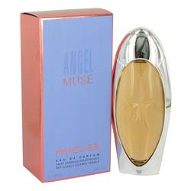

# 

***ANGEL MUSE***

## *Description:*

Angel Muse by Thierry Mugler Perfume. Angel Muse is a reimagining of Thierry Mugler’s classic Angel perfume. Women who found Angel to be too intense will find this perfume softer and more wearable. Created by legendary perfumer Quentin Bisch, Thierry Mugler promises that this is an addictive fragrance will be every woman’s guilty pleasure. The top notes of the perfume are light grapefruit and the juiciness of red fruits. The middle notes of the fragrance are a deliciously sexy combination of rose, hazelnut spread and whipped cream. Sweet vetiver and spicy patchouli in the base notes give the perfume a seductive quality that lingers in the mind. The scent exudes confident sensuality, making it an irresistible scent for a night out with your favorite date. Nevertheless, a playful woman could give herself a light spritz before daytime fun.