***PAAREES PERFUMES***

***THIERRY MUGLER***

***FOR WOMEN***

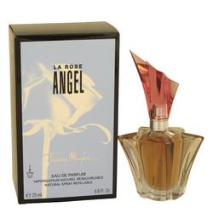

# 

***ANGEL ROSE***

## *Description:*

Angel Rose by Thierry Mugler Perfume. The epitome of grace and elegance, Angel Rose is a scent for days when you want to float through with a feeling of weightlessness. Imbued with a stunning blend of rich and delicate scents, this women's fragrance reflects your ultra-feminine side and enhances your inner mystery. Introduced in 2006 by Thierry Mugler, it blooms softly with a top note of rose, followed by a distinctive note of patchouli. Citrus, pink pepper and coumarin combine to create a gentle and slightly exotic scent.