***PAAREES PERFUMES***

***THIERRY MUGLER***

***FOR WOMEN***

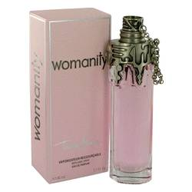

# 

***WOMANITY***

## *Description:*

Womanity by Thierry Mugler Perfume. A sense of timeless elegance is yours when you wear Womanity for women. This striking fragrance offers layers of intensity as notes of fig, fig leaf and fig tree are warmed by the heady scent of caviar. Wear this sophisticated scent for a night out on the town and make a great first impression on everyone you meet. Introduced in 2010, this richly aromatic fragrance from Thierry Mugler celebrates women and entices the senses with its captivating bouquet.