***PAAREES PERFUMES***

***VERSACE***

***FOR MEN***

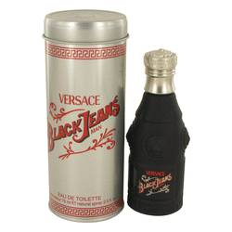

# 

***BLACK JEANS***

## *Description:*

Black Jeans by Versace Cologne. A casual fragrance that can go from day to night with ease, Black Jeans for men was introduced in 1997 by Versace. Ideal for those who prefer to take the lead, this sophisticated scent is perfect for late night dinners or long meetings after work. It combines the upper notes of ginger and lavender with the base notes of tarragon and lemon verbena, which when mixed together create a timeless scent for the active man.