***PAAREES PERFUMES***

***VERSACE***

***FOR MEN***

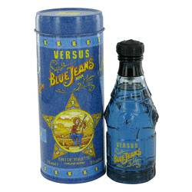

# 

***BLUE JEANS***

## *Description:*

 Blue Jeans by Versace Cologne. Introduced in 1994 by world renowned fashion designer Gianni Versace, Blue Jeans is a men's scent that commands immediate attention. Boasting aromatic fresh and spicy notes with floral and citrus overtures, this daytime scent surrounds you with an unforgettable, smoky aroma that separates you from all of the other men at the office. Wear it to define your effortless, sophisticated fashion sensibilities at the gym, the golf course or a lunchtime date with your new special someone.