***PAAREES PERFUMES***

***VERSACE***

***FOR MEN***

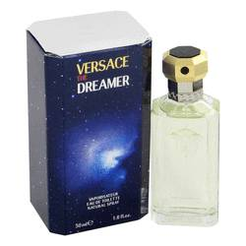

# 

***DREAMER***

## *Description:*

Dreamer by Versace Cologne. Aromatic, sensual and bold, Dreamer, an exciting romantic men's fragrance from the design house of Versace, will heighten your senses and leave you feeling powerful. This sensual fragrance combines a perfect blend of warm and woody notes, such as lavender, Mandarin orange, sage, carnation and tobacco. Introduced in 1996, this masculine fragrance is recommended for daytime and casual wear. As perfect for the office as it is for a lunch date, this scent will not let you down.