***PAAREES PERFUMES***

***VERSACE***

***FOR MEN***

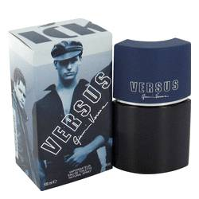

# 

***VERSUS***

## *Description:*

Versus by Versace Cologne. Make a statement and attract attention and admiration everywhere you go with Versus by Versace. Launched in 1991, this celebrated men's fragrance is perfect for wild nights out on the town and casual nights at home with your special someone. It blends together refreshingly fruity notes of mandarin orange, peach and lime with lavender and green notes. Dab on Versus by Versace in the morning to enjoy its scent throughout the entire day. It works well throughout all seasons of the year.