***PAAREES PERFUMES***

***VERSACE***

***FOR WOMEN***

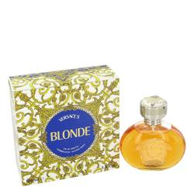

# 

***BLONDE***

## *Description:*

Blonde by Versace Perfume. Have more fun when you wear Blonde, a playful scent for women. Sweet notes of neroli and gardenia toy with bergamot and pitosporum in this amusing blend by Versace. Introduced in 1995, this aroma is perfect to wear any time you want to add a kick to your day. Splash some on as you're getting ready for a productive workday, or dabble it on strategically when you're dressing up for a romantic evening with someone special.