***PAAREES PERFUMES***

***VERSACE***

***FOR WOMEN***

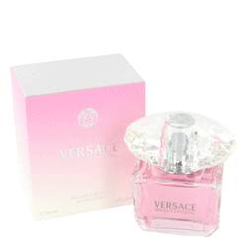

# 

***BRIGHT CRYSTAL***

## *Description:*

Bright Crystal by Versace Perfume. Rejuvenate and refresh your spirit with a spritz of Bright Crystal, a Versace Scent for free-spirited and adventurous women. This crisp, fruity scent was released in 2006 and is designed for everyday wear. Apply it before a long day at the office or a fun night with friends to feel vibrant and lively throughout the day. Bright Crystal starts with the fruity sent of pomegranate and follows up with medium notes of yuzu, peony and freshly picked magnolias.