***PAAREES PERFUMES***

***VERSACE***

***FOR WOMEN***

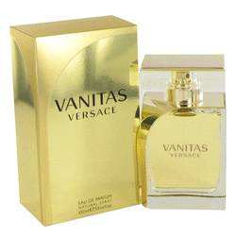

# 

# *Vanitas*

## *Description:*

Vanitas by Versace Perfume. The perfect finishing touch to your formal ensemble, Vanitas offers an air of sophistication and high fashion for women. Designed in 2011 by noted Italian fashion designer Donatella Versace, this luxurious fragrance features a blend of floral and citrus notes to make you the center of attention. High notes of lime and freshly picked freesia begin the scent, while Tiare flower and warm Virginia cedar follow it up. The fragrant aroma of tonka bean, a spice imported from South America, rounds out this upscale scent.