***PAAREES PERFUMES***

***VERSACE***

***FOR WOMEN***

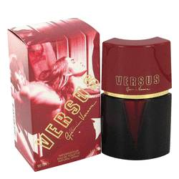

# 

# *Versus*

# *Description:*

Versus by Versace Perfume. Start your with a jolt by spritzing on a dash of Versus from design house of Versace after you step out of your morning shower. This wild and energetic women's fragrance that debuted in 1992 gets you going and has you ready to face your busy day. Fragrant notes of sweet orange blossoms, star apples, juicy kumquats and Centifolia roses are combined to create a tantalizing aroma, and a splash of lemon gives it a kick of citrus to add excitement to your presence.