***PAAREES PERFUMES***

***DAVIDOFF***

***FOR MEN***

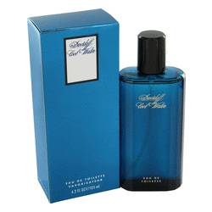

# 

***C00L WATER***

## *Description:*

Cool Water by Davidoff Cologne. Splash on a bit of refreshment with Davidoff Cool Water for men. Launched in 1988 by the design house of Davidoff, this top selling fragrance sports crisp, green notes of sea water, mint, lavender, and coriander for a perfectly balanced scent you can wear anywhere. Cool Water cologne is a versatile, manly scent that can be worn by all different types of men on any occasion. For fans of Davidoff, Cool Water is the perfect signature fragrance. Whether you're busy at work or out on the town until the wee hours of the morning, Cool Water perfume is the perfect well-rounded scent for you.