***PAAREES PERFUMES***

***DAVIDOFF***

***FOR MEN***

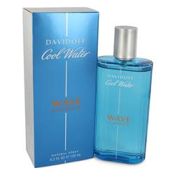

# 

***C00L WATER WAVE***

## *Description:*

Cool Water Wave by Davidoff Cologne. In 2017, Cool Water Wave cologne was released. It brings many aquatic and woody accords around a man’s pulse points. The top notes of the composition include sea notes in addition to Sichuan pepper and grapefruit. The heart consists of juniper and birch leaf. It ends with a resilient base made up of sandalwood and patchouli.