***PAAREES PERFUMES***

***DAVIDOFF***

***FOR MEN***

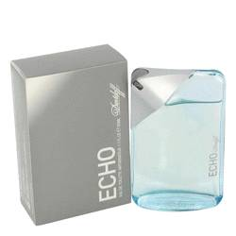

***Echo***

***Description:***

Echo by Davidoff Cologne. Echo by Davidoff is a designer fragrance for confident men. Launched by the Davidoff design house in 2003, it is a perfect blend of spicy and sweet and makes no effort to hide its masculinity. An exotic infusion of nutmeg, chili and spicy black pepper is layered on top of a musk base for a balance of sugar and spice that is much more than just nice. Echo by Davidoff is recommended for daytime wear.