***PAAREES PERFUMES***

***DAVIDOFF***

***FOR MEN***

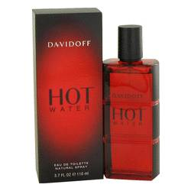

# 

***HOT WATER***

## *Description:*

Hot Water by Davidoff Cologne. Once you splash on the rich, exotic fragrance of Hot Water, you will become intoxicated by this stylized scent made by Davidoff. Introduced in 2009, the fragrance includes a rich infusion of notes, all of which combine to create an original and memorable fragrance offering. Artemisia, basil, absinthe and pimento are all part of this scented blend that's made for the man who wants his fragrance to be painted with provocative and earthy tones.