***PAAREES PERFUMES***

***DAVIDOFF***

***FOR MEN***

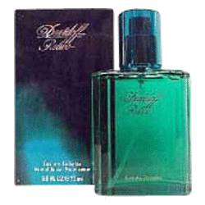

***Relax***

***Description:***

Relax by Davidoff Cologne. Enjoy the subtle, invigorating scent of Relax for men. This stimulating fragrance, which was first introduced in 1990 by the design house of Davidoff, features a refreshing combination of accords from mint, lavender, tarragon, bergamot and zesty lemon to create a masculine scent that is sure to carry you through your active day. Recommended for daytime wear, use Relax anytime you are headed outdoors for adventure, a picnic or for a simple gathering with friends.